Profile of the

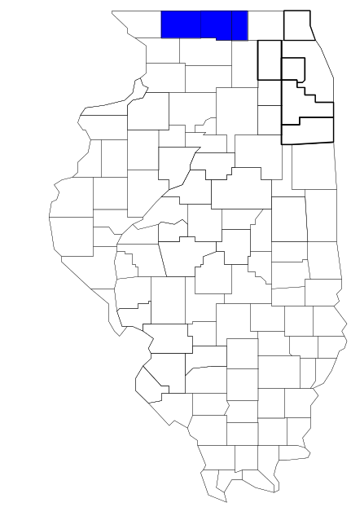State Line Area Narcotics Team

Prepared by

The Research and Analysis Unit of the
Illinois Criminal Justice Information Authority

George H. Ryan, Governor
Peter B. Bensinger, Chairman
Candice M. Kane, Executive Director

March 2001



ILLINOIS
CRIMINAL JUSTICE
INFORMATION AUTHORITY

This project was supported by Grant # 99-DB-BX-0017, awarded to the Illinois Criminal Justice Information Authority by the Bureau of Justice Assistance, Office of Justice Programs, U.S. Department of Justice. The Assistant Attorney General, Office of Justice Programs, coordinates the activities of the following programs, offices and bureaus: Bureau of Justice Assistance, Bureau of Justice Statistics, National Institute of Justice, Office of Juvenile Justice and Delinquency Prevention, and the Office for Victims of Crime. Points of view or opinions contained within this document are those of the authors and do not necessarily represent the official position or policies of the U.S. Department of Justice.

Illinois Criminal Justice Information Authority
120 S. Riverside Plaza, Suite 1016
Chicago, Illinois 60606-3997
Telephone (312) 793-8550
Telefax (312) 793-8422
TDD: (312) 793-4170
World Wide Website http://www.icjia.state.il.us
ACKNOWLEDGMENTS

A number of organizations and individuals put a great deal of effort into the development of this document. The Authority’s Research and Analysis Unit is very grateful for the assistance provided by the following organizations:

Administrative Office of the Illinois Courts
Illinois Department of Human Services’ Office of Alcoholism and Substance Abuse
Illinois Department of Children and Family Services
Illinois Department of Corrections
Illinois State Police
State Line Area Narcotics Team
U.S. Bureau of the Census

In addition, the following individuals were instrumental in gathering, interpreting and presenting these data:

Sharyn Adams

Megan Alderden

Robert Bauer

Alissa Clark

John Condne

Karen Griffiths

Tracy Hahn

Jennifer Hiselman

David Katz

Joseph Kozenczak

Gary Kupsak

Erica Morrow

David Olson

Adrianna Perez

Gerard Ramker

Robert Taylor

CONTENTS

Section Page Number

EXECUTIVE SUMMARY

I. Introduction 1
II. Trends in Violent Index Offenses and Arrests 3
III. Trends in Drug Arrests 6
IV. Trends in Drug Seizures 14
V. Trends in Prosecutions for Drug Offenses 16
VI. Trends in Percent of Convicted Drug Offenders Sentenced to Prison 18
VII. Trends in Drug Treatment Admissions in SLANT Region by Drug Type 23
VIII. Trends in Drug Exposed Births 26
IX. Summary of Drug Situation 27
X. Appendices 30
Map 1 1999 Percent of Illinois' County-level Population Covered by an
Authority-funded Multi-jurisdictional Enforcement Group or Task Force 31
Map 2 1999 Illinois Cannabis Seizure Rates, by County 32
Map 3 1999 Illinois Controlled Substances Seizure Rates, by County 33
Map 4 1999 Illinois Methamphetamine Seizure Rates, by County 34
XI. Bibliography 35

LIST OF FIGURES

Figure Page Number

Figure 1. Violent Index Offense Rates for Participating and Non-participating Agencies in Region Covered by SLANT 3
Figure 2. 1999 Violent Index Offenses* Reported by Participating and Non-participating Agencies in Region Covered by SLANT 4
Figure 3. Violent Index Arrest Rates for Participating and Non-participating Agencies in Region Covered by SLANT 5
Figure 4. 1999 Violent Index Arrests* Reported by Participating and Non-participating Agencies in Region Covered by SLANT 5
Figure 5. Total Drug Arrest Rates for SLANT and Participating and Non-participating Agencies in Region Covered by SLANT 7
Figure 6. 1999 Drug Arrests* Reported by Participating and Non-participating Agencies in Region Covered by SLANT 8
Figure 7. Total 1999 Drug Arrests* Reported by Participating and Non-participating Agencies in Region Covered by SLANT, by Drug Type 8
Figure 8. Drug Arrests by SLANT 9
Figure 9. Percent of Total Drug Arrests Accounted for by SLANT 10
Figure 10. Cannabis Arrests Rates in the Region Covered by SLANT as Reported by Participating Agencies, Non-participating Agencies and SLANT 11
Figure 11. Percent of Cannabis Arrests Accounted for by SLANT
11
Figure 12. Controlled Substances Arrest Rates in the Region Covered by SLANT as Reported by Participating Agencies, Non-participating Agencies and SLANT 12
Figure 13. Percent of Controlled Substances Arrests Accounted for by SLANT 13
Figure 14. SLANT Drug Arrests for Possession versus Delivery, by Drug Type 13
Figure 15. Cannabis Seized and Submitted to ISP by Boone, Stephenson and Winnebago Counties and Seized by SLANT 14
Figure 16. Powder and Crack Cocaine Seized and Submitted to ISP by Boone, Stephenson and Winnebago Counties and Seized by SLANT 15
Figure 17. Number of Felony Filings in Boone, Stephenson and Winnebago Counties 16
Figure 18. Total SLANT Drug Arrests and Percentage of Arrests Resulting in Prosecution 17
Figure 19. Sentences Imposed on Felons Convicted in Boone, Stephenson and Winnebago Counties
18
Figure 20. Sentences Imposed on Convicted SLANT Drug Offenders 19
Figure 21. Number of Drug Offenders Committed to IDOC by SLANT and Region Covered by SLANT 20
Figure 22. Drug Offenders as a Percent of Total IDOC Commitments from Boone, Stephenson and Winnebago Counties 21
Figure 23. Drug Offenders Committed to IDOC from Boone, Stephenson and Winnebago Counties, by Offense Class 22
Figure 24. Substance Abuse Treatment Admissions from Boone, Stephenson and Winnebago Counties 23
Figure 25. Comparison of Drug Arrests by SLANT and Participating and Non-participating Agencies vs. Drug Abuse Treatment Admissions in Boone, Stephenson and Winnebago Counties 25
Figure 26. Cases of Drug-Exposed Infants in Boone, Stephenson and Winnebago Counties 26
Figure 27. Availability of Drugs in Illinois, 1998 27
Figure 28. Price Per Gram in Illinois, 1998 28

EXECUTIVE SUMMARY

Since 1989, the Authority’s Research and Analysis Unit has received funds under the federal Anti-Drug Abuse Act of 1988 to document the extent and nature of drug and violent crime in Illinois and the criminal justice system’s response to these offenses. As a result of these efforts, the Authority has amassed a large amount of data measuring the extent and nature of drug and violent crime in Illinois and the impact these crimes have had on the criminal justice system. In addition, as part of its monitoring and evaluation efforts, the Authority also requires funded programs to submit monthly data reports describing their activities and accomplishments. This profile is intended to provide a general overview of the drug and violent crime problem in the jurisdictions covered by Illinois’ MEGs and task forces, and the response to these problems by the units.

Although the data presented in this report are by no means inclusive of all indicators, they do provide a general overview of drug and violent crime and the response and impact of the criminal justice system. The following represent general conclusions that can be made based on the data analyzed for this report.

- In 1999, five local Illinois police agencies participated in SLANT (a participating agency is defined as one that contributes either personnel or financial resources to SLANT). Officers assigned to SLANT (totaling 24 in 1999, 6 from participating agencies) accounted for four percent of the total number of sworn police officers working for agencies participating in SLANT.

- The violent Index offense rate was collectively higher across jurisdictions that did not participate in SLANT than among the combined jurisdictions that did participate in SLANT (page 3).

- The drug arrest rate was higher collectively in those jurisdictions that did not participate in SLANT than in those jurisdictions participating in SLANT. The drug arrest rate achieved by SLANT was less than one-half the rate achieved across agencies participating in SLANT, meaning that the unit made nearly one-half as many arrests for violations of the Cannabis Control and Controlled Substances Acts, combined, with only six officers (page 6).

- When comparing the types of drug offenders arrested by those agencies participating in SLANT, those agencies not participating, and SLANT, it was found that SLANT tended to target and arrest more serious drug law violators in 1999, specifically violators of the Controlled Substances Act, which tend to be felony-level offenses (page 9).

- The majority of all drug arrests reported by SLANT, for either violations of the Cannabis Control Act or the Controlled Substances Act, involve drug sale or delivery (page 13).

- Between 1993 and 1999, the amount of cannabis seized by SLANT decreased, while the amount of cocaine seized by SLANT increased (pages 14 and 15).

- Between 1990 and 1999, the majority of all drug arrests by SLANT resulted in prosecution. Of these SLANT drug offender prosecutions, 62 percent were for violations of Controlled Substances Act. In addition, between 1989 and 1999, more than three-quarters of all drug offenders who were prosecuted as a result of SLANT activity were convicted (page 17).

- In 1999, among those SLANT drug offenders convicted and sentenced, prison sentences accounted for the largest proportion (53 percent), followed by probation sentences (24 percent) and jail sentences (24 percent) (page 19).

- Between 1989 and 1999, prison sentences resulting from SLANT cases accounted for 24 percent of all drug-law violators sent to prison from the region where SLANT operates (page 20).

- Unlike the arrests made by the participating and non-participating agencies, the arrests made by SLANT tended to involve the substances considered to be most serious (i.e., felony versus misdemeanor) and the substances for which a large proportion of community residents were seeking and receiving substance abuse treatment in 1999 (page 24).

I. Introduction

The State Line Area Narcotics Team (SLANT) covers the Illinois counties of Boone, Stephenson and Winnebago. Combined, these counties had a 1999 total population of 355,281 – 7 percent more than in 1990. In 1999, five local Illinois police agencies participated in SLANT. These include the Boone County Sheriff's Office, the Stephenson County Sheriff's Office and the following municipal police departments: Loves Park, Roscoe and Freeport. These agencies served nearly 23 percent of the population in the three-county region covered by SLANT in 1999 (see Map 1 on page 31). In addition, the following Wisconsin law enforcement agencies also participate in SLANT: the Green County Sheriff's Office, the Rock County Sheriff's Office and the Monroe and Beloit police departments. A participating agency is defined as one that contributes either personnel or financial resources to SLANT.

In addition to agencies that participate in SLANT, these Illinois counties are served by 12 additional police departments that do not participate in SLANT. According to the Illinois State Police, county sheriffs and local police departments, in the three-county region covered by SLANT, combined, employed 642 full-time police officers as of Oct. 31, 1999. In comparison, there were 24 officers assigned to SLANT in 1999, seven of which were assigned by participating agencies, ten from the Illinois State Police (ISP) and seven from Wisconsin law enforcement agencies. Thus, the officers assigned to SLANT during 1999 accounted for a relatively small proportion -- less than 4 percent -- of the total number of sworn police officers working in the participating police departments, and the region as a whole

In addition to administering federal block-grant funds that come to Illinois for crime control initiatives, the Illinois Criminal Justice Information Authority is also responsible for providing policymakers, criminal justice professionals and others with information, tools and technology needed to make effective decisions that improve the quality of criminal justice in Illinois. The Authority provides an objective system-wide forum for identifying critical problems in criminal justice, developing coordinated and cost-effective strategies, and implementing and evaluating solutions to those problems. The specific powers and duties of the Authority are delineated in the Illinois Criminal Justice Information Act (Illinois Compiled Statutes, Ch. 20, Sec. 3930). Two of the Authority’s many responsibilities are serving as a clearinghouse of information and research on criminal justice and undertaking research studies to improve the administration of criminal justice.

Since 1989, the Authority’s Research and Analysis Unit has received funds under the federal Anti-Drug Abuse Act of 1988 to document the extent and nature of drug and violent crime in Illinois and the criminal justice system’s response to these offenses. As a result of these efforts, the Authority has amassed a large amount of data measuring the extent and nature of drug and violent crime in Illinois and the impact these crimes have had on the criminal justice system. In addition, as part of its monitoring and evaluation efforts, the Authority also requires funded programs to submit monthly data reports describing their activities and accomplishments. To put this information into the hands of Metropolitan Enforcement Group (MEG) and drug task force directors and policy board members, the Authority’s Research and Analysis Unit has developed profiles – of which this is one – for each MEG and task force. The profile is intended to provide a general overview of the drug and violent crime problem in the jurisdictions covered by Illinois’ MEGs and task forces, and the response to these problems by the units.

While the data presented in this report are by no means inclusive of all indicators, they do provide a general overview of drug and violent crime and the response and impact of the criminal justice system. In addition, these data are readily available and consistently defined through existing statewide data collection mechanisms. Some data presented in this profile have been analyzed differently than in previous years; therefore, caution must be taken when comparing numbers presented with previous profiles.
While a considerable amount of the information presented in this profile has been provided to the Authority by SLANT, a number of state agencies have also provided data to the Authority that are included in this report. Specifically, the Illinois State Police, the Administrative Office of the Illinois Courts, the Illinois Department of Human Services’ Office of Alcoholism and Substance Abuse, the Illinois Department of Corrections and the Illinois Department of Children and Family Services all provided data used to develop this profile. The support and cooperation of these agencies and their staffs have helped make this report an informative and timely source of information on the activities of the criminal justice system in Illinois.

- Trends in Violent Index Offenses and Arrests

While most of Illinois’ Metropolitan Enforcement Groups and drug task forces are primarily involved in drug enforcement activities, it is clear that the relationship between drugs and violence is particularly evident in a number of Illinois communities. In addition, a number of MEGs and task forces have increased their involvement in the investigation of violent crime, particularly that associated with gang activity and violence related to drug distribution, sale and turf battles. One of the most commonly used indicators of the level of crime in a particular jurisdiction is the number of Index offenses reported to the police. In Illinois, as part of the Illinois Uniform Crime Reporting (I-UCR) program, every law enforcement agency in the state is required to report crime data monthly to the Illinois State Police (ISP). There are eight separate offenses that constitute the Crime Index, including murder, criminal sexual assault, robbery, aggravated assault (violent Index offenses), burglary, theft, motor vehicle theft and arson (property Index offenses). Although these eight offenses do not account for all crimes reported to the police, they are considered to be the most serious, frequent, pervasive and consistently defined by different law enforcement agencies.

In 1999, the total number of violent Index offenses reported to the police in the three-county region where SLANT operates totaled 2,005, a 33 percent decrease from the 2,977 offenses reported in 1993. Similar to most other regions across Illinois, aggravated assaults accounted for the majority of violent Index offenses reported to the police between 1993 and 1999. During the period examined, aggravated assaults accounted for 56 percent of reported violent Index offenses, while 29 percent were robberies.

During the period analyzed, the violent Index offense rate for the region covered by SLANT decreased 35 percent, from 866 offenses per 100,000 population in 1993 to 564 offenses per 100,000 population in 1999. Similarly, the violent Index offense rate in the participating agencies decreased 22 percent, from 444 to 345 offenses per 100,000 population, while the rate in the non-participating agencies decreased 36 percent, from 988 to 631 offenses per 100,000 population (Figure 1). Thus, the violent Index offense rate was collectively higher across the jurisdictions that did not participate in SLANT than it was among the combined jurisdictions that did participate in SLANT.
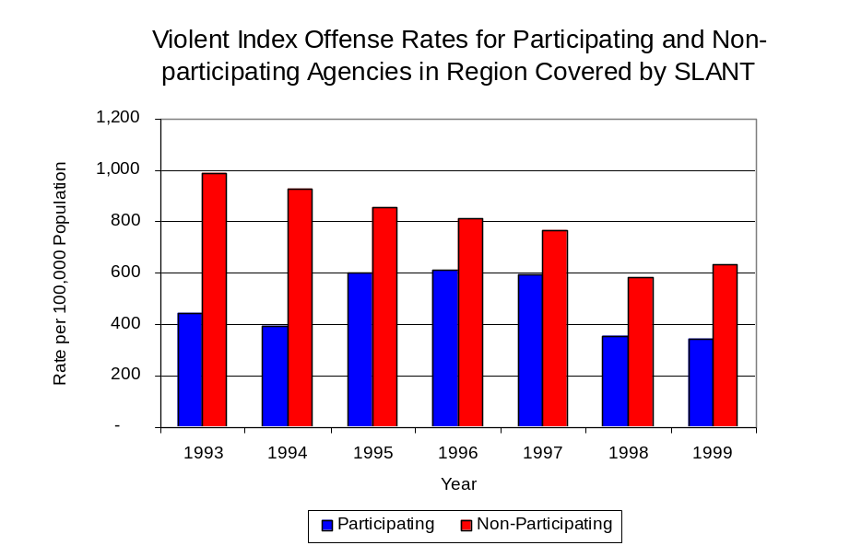
Source: ICJIA calculations using
Illinois State Police and U.S. Census Bureau data
Figure 1
Across the 17 individual local law enforcement agencies covered by SLANT’s jurisdiction, three agencies, the Rockford Police Department, the Freeport Police Department and the Winnebago County Sheriff's Office, accounted for 88 percent of all violent offenses reported to the police (Figure 2). Eight agencies had fewer than 15 violent offenses reported in 1999 and are excluded from Figure 2. When controlling for differences in the populations served by these law enforcement agencies, the violent Index offense rate ranged from zero in three agencies to 1,005 violent Index offenses per 100,000 population in Rockford.
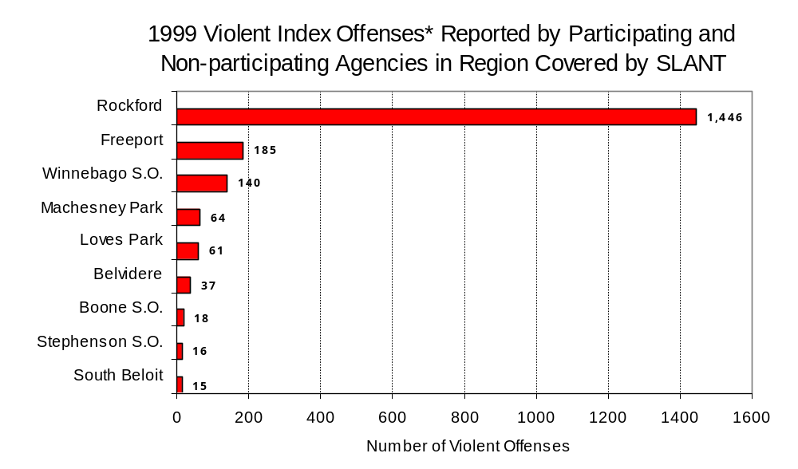
Source: Illinois State Police *Agencies reporting 15 or more violent offenses
Figure 2

An indicator of the workload that law enforcement agencies place on other components of the justice system is the number of arrests made by police, including those for violent and property Index offenses and drug offenses. Unlike offenses, which are what police must respond to, arrests represent those offenders who may eventually be processed through other components of the justice system, including the courts, county jails, and state and local correctional programs.

Between 1993 and 1999, the number of arrests for violent Index offenses made by law enforcement agencies in the region covered by SLANT decreased 20 percent, from 883 to 702. As with reported violent Index offenses, the majority (72 percent) of violent Index arrests were for aggravated assaults, followed by robberies (17 percent).

During the period analyzed, the violent Index arrest rate for the region covered by SLANT decreased 23 percent, from 257 arrests per 100,000 population in 1993 to 198 arrests per 100,000 population in 1999. Similarly, the violent Index arrest rate in the participating agencies decreased 8 percent, from 146 to 135 arrests per 100,000 population, while the rate in the non-participating agencies decreased 25 percent, from 289 to 217 arrests per 100,000 population (Figure 3).

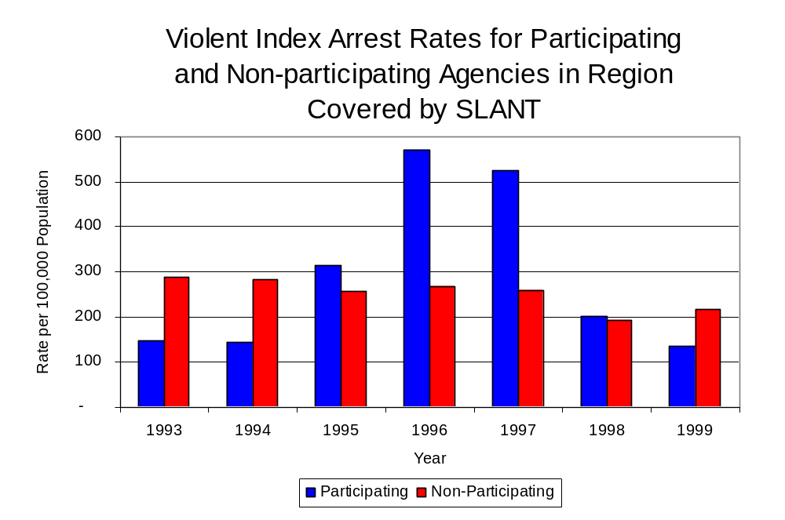
Similar to the number of violent Index offenses, the majority (87 percent) of arrests for violent Index offenses occurring in the three-county region covered by SLANT were made by three agencies. Ten agencies had fewer than 15 arrests for violent Index offenses reported in 1999 and are excluded from Figure 4. Of the 702 violent Index arrests made in 1999, the Rockford Police Department accounted for the majority (66 percent), followed by the Winnebago County Sheriff’s Office (11 percent) and the Freeport Police Department (10 percent) (Figure 4).
Figure 3
Source: ICJIA calculations using
Illinois State Police and U. S. Census Bureau data

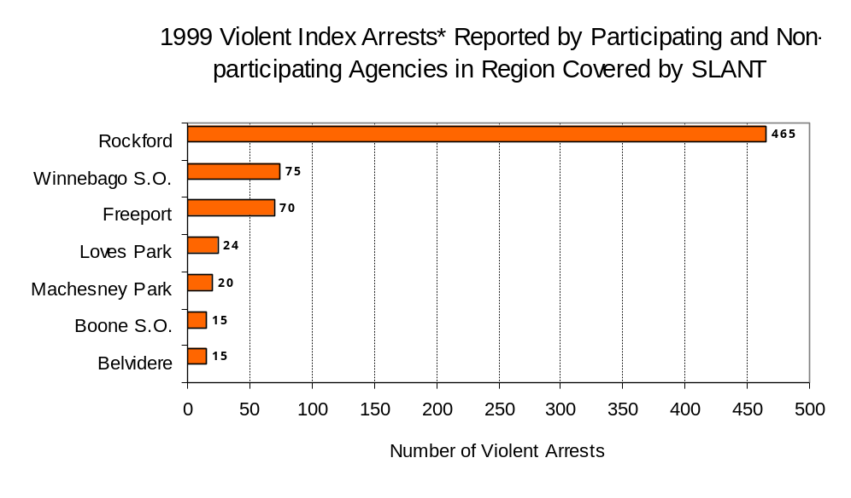
Figure 4
Source: Illinois State Police *Agencies reporting 15 or more violent offenses
III. Trends in Drug Arrests

There are two sources of drug arrest data presented in this section. One source is the Illinois Uniform Crime Reporting (I-UCR) program that includes information submitted by local law enforcement agencies on the number of persons arrested for violations of Illinois’ Cannabis Control Act, Controlled Substances Act, Hypodermic Syringes and Needles Act, and Drug Paraphernalia Control Act. In addition, data on drug arrests made by Illinois’ MEGs and task forces are reported to the Illinois Criminal Justice Information Authority. In some jurisdictions, arrests made by the MEG or task force may be reported by both local law enforcement agencies through the I-UCR and to the Authority by the unit. In other jurisdictions, arrests made by the MEG or task force are only reported to the Authority by the unit. Therefore, in some instances drug arrests may be double counted – included in both local agency statistics reported to I-UCR and those of the MEG or task force. Currently there is no mechanism in place to ensure that drug arrest statistics are not being duplicated at both the local agency and MEG/task force level. This should be kept in mind when interpreting the information presented in the following section.

The majority of drug offenses in Illinois are violations of either the Cannabis Control Act – which prohibits the possession, sale and cultivation of marijuana – or the Controlled Substances Act – which prohibits the possession, sale, distribution or manufacture of all other illegal drugs, such as cocaine and opiates. Illinois also has various other laws prohibiting other drug-related activity. These include the Hypodermic Syringes and Needles Act – which prohibits the possession or sale of hypodermic instruments – and the Drug Paraphernalia Control Act – which prohibits the possession, sale or delivery of drug paraphernalia. In general, violations of Illinois Controlled Substances Act are considered to be more serious, since they primarily involve cocaine, heroin, methamphetamine, and hallucinogens, and are almost all classified under Illinois law as felonies. The majority of cannabis and drug paraphernalia offenses encountered by police, on the other hand, tend to be misdemeanor-level offenses.

In 1999, local law enforcement agencies in the counties covered by SLANT reported 1,807 arrests for drug law violations, more than triple the number in 1993 (734 arrests). Between 1993 and 1999, arrests for violations of Illinois’ Cannabis Control Act out-numbered arrests for violations of the Controlled Substances Act in four of the seven years analyzed in Boone, Stephenson and Winnebago counties. During the same period, the number of arrests for violations of the Cannabis Control Act in these three counties combined more than doubled, from 357 to 1,119. Arrests for violations of the Controlled Substances Act in the three counties combined increased 82 percent, from 377 to 688. In addition, arrests for violations of the Drug Paraphernalia Control Act, enacted in 1993, increased dramatically from 45 in 1993 to 703 in 1999. Much of this increase can be attributed to a 1994 addition to the Drug Paraphernalia Control Act, which included the possession of drug paraphernalia as a violation.

Because arrests for violations of the Drug Paraphernalia Control Act are frequently made in conjunction with other drug offense arrests, these arrests may be double-counted, thus skewing the actual number of drug arrests. Therefore, only arrests for violations of the Cannabis Control Act and Controlled Substances Act will be used for drug arrest comparisons between SLANT and the participating and non-participating agencies.

During the period analyzed, the drug arrest rate for the Cannabis Control and Controlled Substances Acts combined, in the region covered by SLANT more than doubled, from 213 arrests per 100,000 population in 1993 to 509 arrests per 100,000 population in 1999. Similarly, the drug arrest rate in the participating and non-participating agencies also more than doubled, from 203 to 422 arrests per 100,000 population and 217 to 535 arrests per 100,000 population, respectively. The arrest rate for SLANT, on the other hand, increased 77 percent, from 103 to 173 arrests per 100,000 population (Figure 5). Thus, the drug arrest rate tended to be higher collectively in the jurisdictions that did not participate in SLANT than in those jurisdictions that did participate in SLANT. Also, the drug arrest rate achieved by SLANT was less than one-half the rate experienced by the participating agencies, meaning the unit made nearly one-half as many arrests for violations of the Cannabis and Controlled Substances Acts, with 24 officers, as did all of the participating agencies combined.
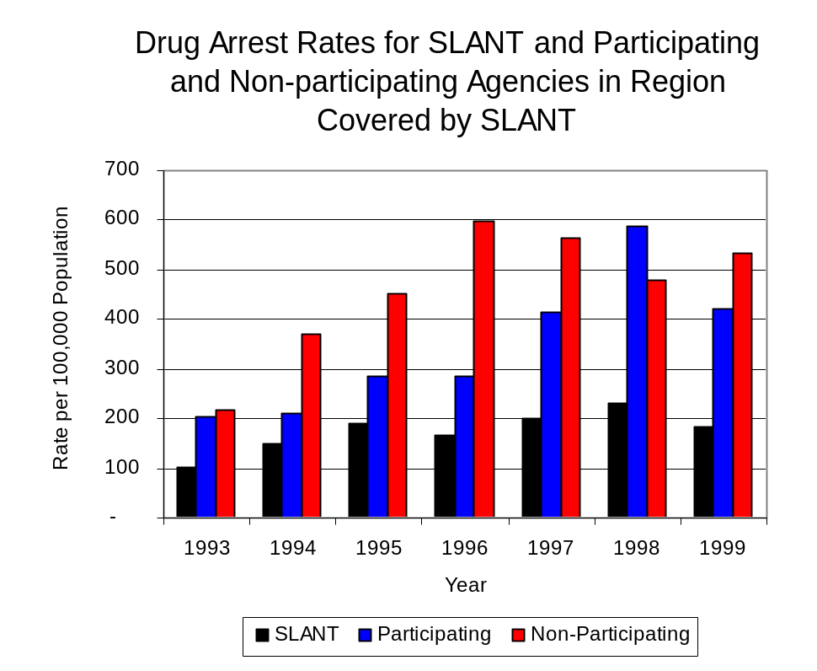
Source: ICJIA calculations using Illinois State Police, SLANT and U.S. Census Bureau data
Figure 5

Across the individual local law enforcement agencies in the region covered by SLANT, the number of total cannabis and controlled substance arrests ranged from three to 1,012. Of the 1,807 drug arrests made during 1999 in the three-county region, four agencies accounted for 81 percent of these drug arrests. Eight agencies had fewer than 20 drug arrests reported in 1999 and are excluded from Figure 6. Rockford accounted for more than one-half (56 percent), while the Winnebago County Sheriff’s Office accounted for 10 percent and Belvidere and Freeport each accounted for 7 percent of cannabis and controlled substance arrests in Boone, Stephenson and Winnebago counties (Figure 6). Among the nine agencies with the highest number of drug arrests during 1999, four participated in SLANT.

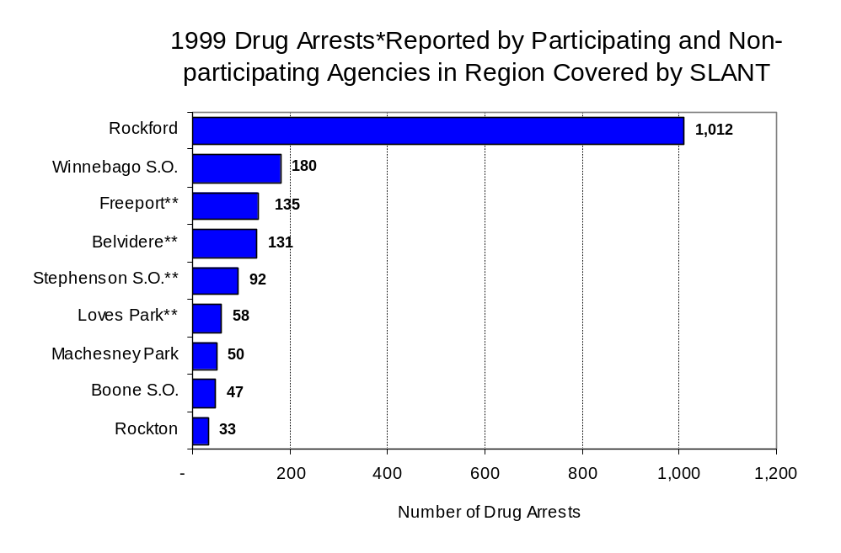
Figure 6
Source: Illinois State Police *Agencies reporting 20 or more drug arrests
**Agencies participating in SLANT

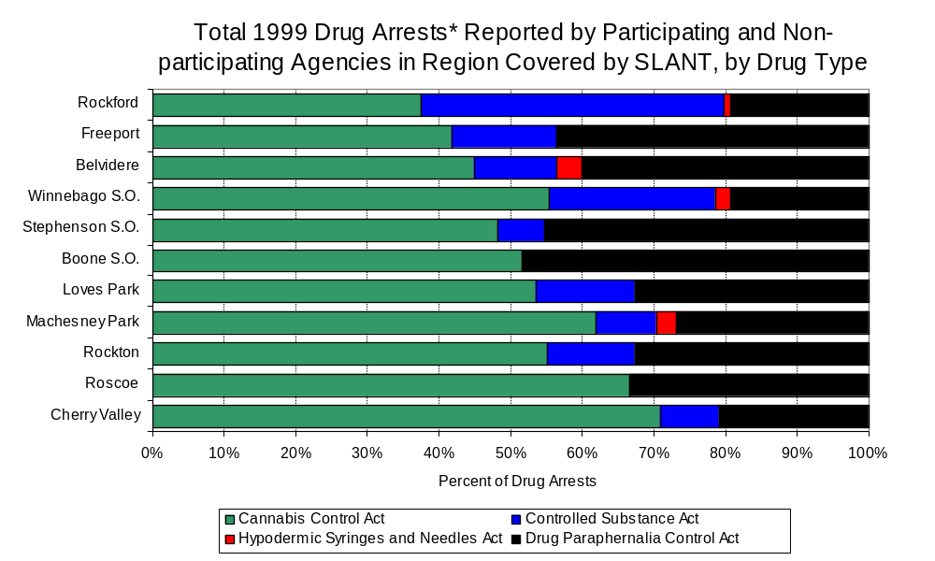
In addition to the dramatic difference in the number of drug arrests made, there are also differences in the types of arrests for drug law violations across the agencies in the region. In 1999, violations of the Cannabis Control Act accounted for the largest proportion of arrests across most individual agencies in the region covered by SLANT (Figure 7).
Figure 7
Source: Illinois State Police *Agencies reporting 20 or more drug arrests
Between 1993 and 1999, the number of combined cannabis and controlled substances arrests made by SLANT nearly doubled, from 80 to 152. Unlike drug arrests made by most local police departments in the region, violations of the Controlled Substances Act accounted for the majority of drug arrests made by SLANT throughout most of the period analyzed. During the period analyzed, the number of SLANT arrests for violations of the Cannabis Control Act more than doubled, from 26 to 56, while arrests for violations of the Controlled Substances Act increased 78 percent, from 54 to 96 (Figure 8). Thus, arrests by SLANT were more likely than arrests by either participating or non-participating agencies to involve violations of Illinois’ Controlled Substances Act, as opposed to the Cannabis Control Act. One interpretation of this pattern is that SLANT is more focused in who they are targeting and arresting than local departments, and are also getting a more serious drug law violator, since violations of the Controlled Substances Act are more likely to involve felony-level offenses.
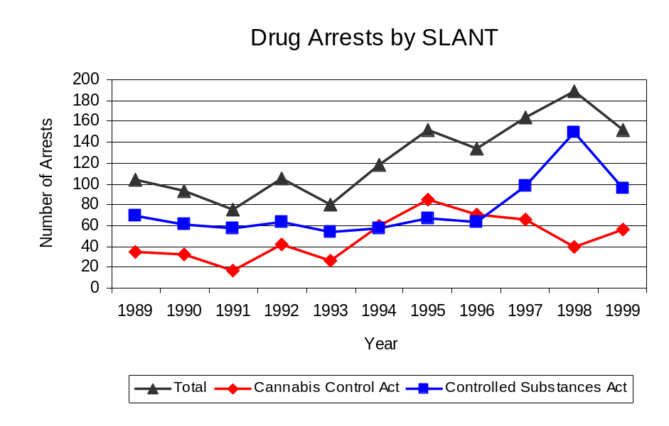
Source: SLANT
Figure 8
Between 1993 and 1999, the proportion of drug arrests accounted for by violations of the Controlled Substances Act decreased for participating and non-participating agencies as well as SLANT. In 1999, 63 percent of the drug arrests made by SLANT were for violations of the Controlled Substances Act, compared to 68 percent in 1993. Similarly, in 1999, arrests for violations of the Controlled Substances Act accounted for 17 percent of the drug arrests made in the participating agencies and 43 percent for the non-participating agencies, compared to 28 percent and 58 percent, respectively, in 1993.

The data presented on the following page represent the percent of total drug arrests made by agencies participating in SLANT accounted for by SLANT. An upper and lower bound is shown in Figure 9 which accounts for whether or not the units numbers are counted as part of the UCR submissions made by local departments (which is unknown at this point). The upper bound indicates the percentage of arrests if all of the SLANT arrests are included in the local UCR submissions. The lower bound indicates the percentage if none of the SLANT arrests are included in the local UCR submissions. It is estimated that the proportion of all drug arrests across participating agencies accounted for by SLANT was between 34 to 51 percent in 1993, but decreased to between 30 to 43 percent in 1999. Thus, despite the fact that the officers assigned to SLANT accounted for a small proportion of total officers in the region, they accounted for a relatively large proportion of the drug arrests in the region.

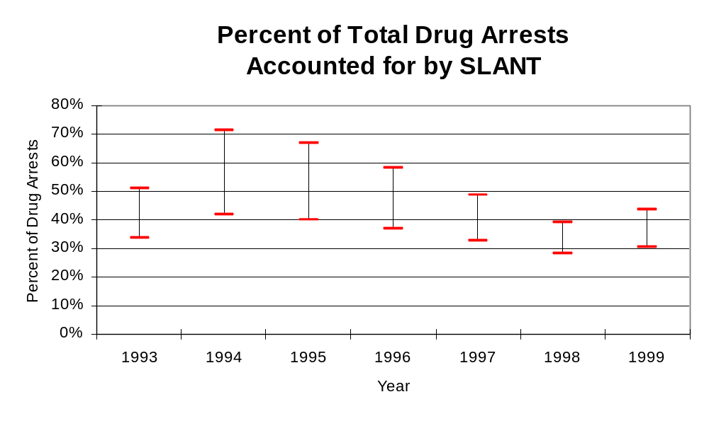
Figure 9
Source: ICJIA calculations using
Illinois State Police and SLANT data
The number of arrests for violations of Illinois’ Cannabis Control Act in Boone, Stephenson and Winnebago counties totaled 1,119 in 1999, more than triple the 357 arrests made for cannabis violations in 1993. Between 1993 and 1999, the proportion of all drug arrests accounted for by violations of the Cannabis Control Act in the three-county region increased from 49 percent to 62 percent. Agencies not participating in SLANT accounted for the largest portion (74 percent) of the total number of arrests for cannabis violations. SLANT reported a total of 56 arrests for cannabis violations in 1999, 37 percent of the unit's drug arrests.

During the period analyzed, the cannabis arrest rate for the region covered by SLANT more than tripled, from 104 arrests per 100,000 population in 1993 to 315 arrests per 100,000 population in 1999. The cannabis arrest rate in the participating agencies more than doubled, from 146 to 352 arrests per 100,000 population, while the arrest rate in the non-participating agencies more than tripled from 92 to 304 arrests per 100,000 population. The cannabis arrest rate for SLANT, on the other hand, doubled, from 34 to 68 arrests per 100,000 population (Figure 10). Thus, the arrest rate for violations of the Cannabis Control Act was collectively higher in the jurisdictions of the non-participating agencies than in the combined area served by participating agencies.

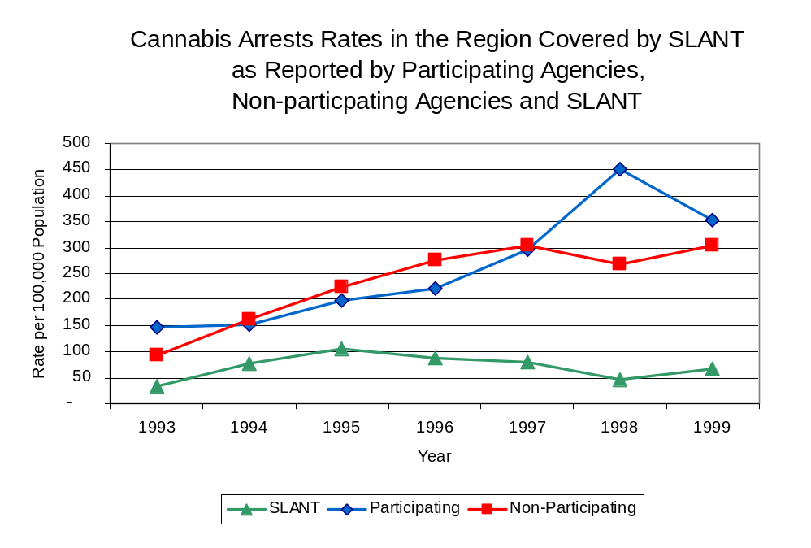
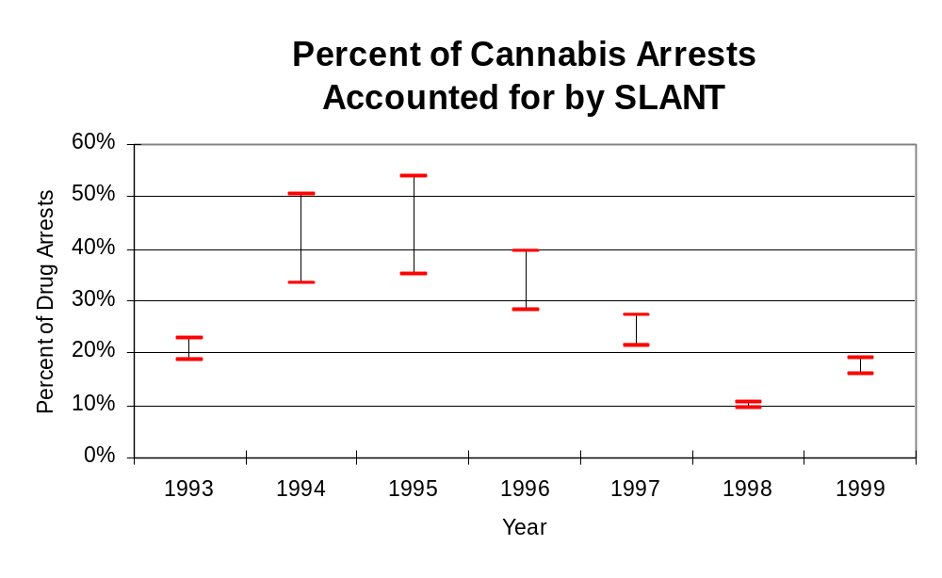
The data presented in Figure 11 represent the percent of cannabis arrests made by agencies participating in SLANT accounted for by SLANT. An upper and lower bound is shown which accounts for whether or not the unit’s numbers are counted as part of the UCR submissions made by local departments (which is unknown at this point). The upper bound indicates the percentage of arrests if all of the SLANT arrests are included in the local UCR submissions. The lower bound indicates the percentage if none of the SLANT arrests are included in the local UCR submissions. It is estimated that the proportion of cannabis arrests across participating agencies accounted for by SLANT was between 19 to 23 percent in 1993, but decreased slightly to between 16 to 19 percent in 1999.
Source: ICJIA calculations using
Illinois State Police and SLANT data
Figure 10
Figure 11
Source: ICJIA calculations using
Illinois State Police and SLANT data
In Boone, Stephenson and Winnebago counties the number of arrests for violations of Illinois’ Controlled Substances Act increased 82 percent between 1993 and 1999, from 377 to 688. Between 1993 and 1999, the proportion of all drug arrests accounted for by violations of the Controlled Substances Act in the three-county region decreased from 51 percent to 38 percent. In 1999, SLANT reported 96 arrests for controlled substance violations, 63 percent of all drug arrests reported to the Authority by the unit.

Between 1993 and 1999, the arrest rate for controlled substances act violations for the region covered by SLANT increased 77 percent, from 110 to 194 arrests per 100,000 population (Figure 12). The controlled substances arrest rate in the participating agencies increased 23 percent, from 57 to 70 arrests per 100,000 population, while the arrest rate in the non-participating agencies nearly doubled, from 125 to 231 arrests per 100,000 population. The controlled substances arrest rate for SLANT increased 66 percent, from 70 to 116 arrests per 100,000 population (Figure 12). Thus, the arrest rate for violations of the Controlled Substances Act was dramatically higher in the non-participating units than the participating agencies. Also, the arrest rate for violations of the Controlled Substances Act achieved by SLANT was 66 percent higher than the rate experienced by the participating agencies, meaning that the unit made two-thirds as many arrests for violations of the Controlled Substances Acts, with six officers, as did all of the participating agencies combined.
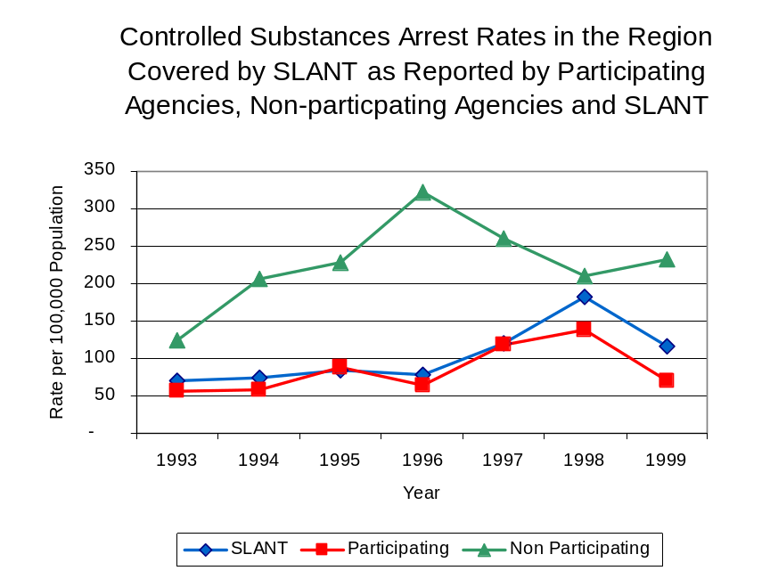
Figure 12
Source: ICJIA calculations using Illinois State Police and SLANT data

The data presented in Figure 13 represent the percent of controlled substances arrests made agencies participating in SLANT accounted for by SLANT. An upper and lower bound is shown which accounts for whether or not the units numbers are counted as part of the UCR submissions made by local departments (which is unknown at this point). The upper bound indicates the percentage of arrests if all of the SLANT arrests are included in the local UCR submissions. The lower bound indicates the percentage if none of the SLANT arrests are included in the local UCR submissions. Because values of the upper bound exceed 100 percent, it is believed that SLANT controlled substances arrests are included in local agency UCR submissions and, according to the lower bound, it is estimated that the proportion of

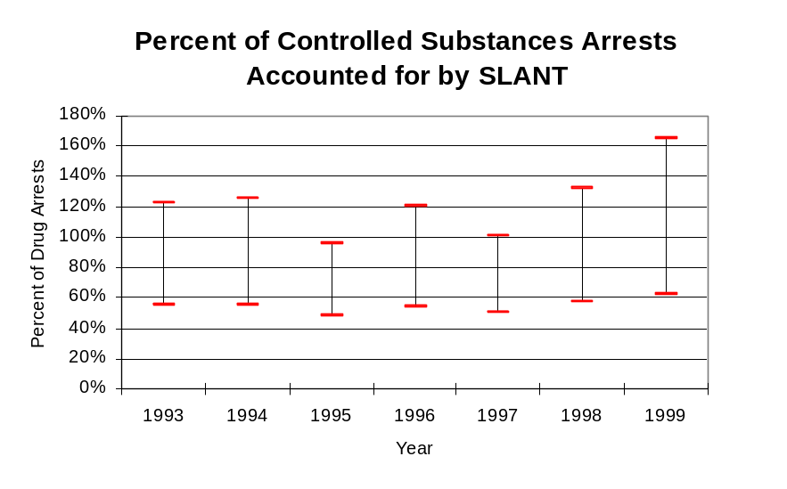
controlled substances arrests across participating agencies accounted for by SLANT remained relatively stable throughout the period analyzed accounting for approximately 55 percent in 1993, and increased to 62 percent in 1999.
Figure 13
Source: ICJIA calculations using
Illinois State Police and SLANT data

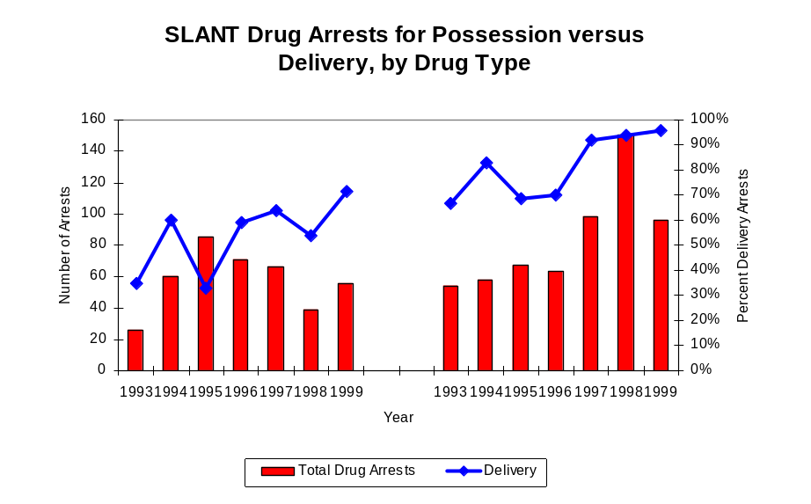
The majority of all drug arrests reported by SLANT are for delivery. Between 1993 and 1999, the number of drug delivery arrests made by SLANT nearly tripled, from 45 to 132. Arrests for drug delivery accounted for nearly three-quarters (72 percent) of all drug arrests made by SLANT between 1993 and 1999. When cannabis and controlled substance arrests were examined separately, during the period analyzed, arrests for delivery of controlled substances accounted for 81 percent of the total number of arrests made for violations of the Controlled Substance Act, whereas, arrests for the delivery of cannabis accounted for 54 percent of all arrests for violations of the Cannabis Act. However, the proportion of delivery arrests has increased during the period analyzed. The proportion of arrests for delivery of cannabis more than doubled from 35 percent in 1993 to 71 percent in 1999, while the proportion of arrests for delivery of controlled substances increased from 67 to 96 percent between 1993 and 1999.
Figure 14
Source: ICJIA calculations using SLANT data
Cannabis Control Act

Controlled Substances Act

IV. Trends in Drug Seizures

Drugs seized by law enforcement agencies are another indicator of the extent and nature of illegal drug trade in a jurisdiction. When illegal drugs are seized by law enforcement agencies, all or a portion of the total amount seized is submitted to a crime lab for analysis. Most agencies submit drugs to one of the Illinois State Police crime labs. These labs record the quantity of drugs submitted from each county. This section discusses trends in the quantities of illegal drugs seized and submitted to the Illinois State Police from local law enforcement agencies in Boone, Stephenson and Winnebago counties as well as the quantities of drugs seized by SLANT. It is important to note, however, that while SLANT data report the total quantities of drugs actually seized, local agency data only represent the quantities of seized drugs that are submitted to the Illinois State Police for analysis. County-level cannabis, cocaine and methamphetamine seizure rates for Illinois' 102 counties are provided in maps located in the Appendix of this report.

As in most Illinois jurisdictions, cannabis accounts for the majority of illegal drugs seized in the three-county region covered by SLANT. The quantity of cannabis seized and submitted by law enforcement agencies in Boone, Stephenson and Winnebago counties increased 8 percent, from 84,393 grams in 1993 to 91,191 grams in 1999. However, the quantity of cannabis seized by SLANT decreased 71 percent between 1993 and 1999, from 329,753 grams to 97,056 grams despite jumping to more than 32 million grams seized in 1995 (Figure 15). In 1999, SLANT's cannabis seizure rate of 117,009 grams per 100,000 population was more than triple the statewide cannabis seizure rate of 31,533 grams per 100,000 population and nearly quadruple the seizure rate of 25,667 grams per 100,000 population in the three-county region covered by SLANT. (Note: In order to adequately reflect the seizure data on the graph below, it was necessary to set the Y-axis scale to 500,000. Therefore, it should be noted that SLANT reported more than 32 million grams of cannabis were seized in 1995) (Map 2).
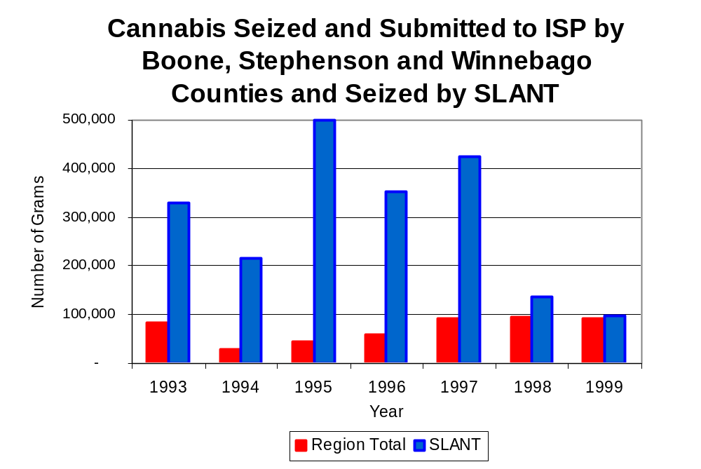
Figure 15
Source: Illinois State Police and SLANT
Between 1993 and 1999, a combination of crack and powder cocaine has accounted for a small proportion of drugs seized in the three-county region covered by SLANT. However, the quantity of cocaine seized and submitted by law enforcement agencies in Boone, Stephenson and Winnebago counties more than tripled, from 2,365 grams in 1993 to 7,454 grams in 1999. Between 1993 and 1999, the quantity of cocaine seized by SLANT increased 26 percent, from 3,507 grams to 4,413 grams.

The proportion of all cocaine seized in the three-county region covered by SLANT accounted for by powder cocaine remained relatively stable between 1993 and 1999, increasing from 77 percent in 1993 to 85 percent in 1999, whereas SLANT seizures revealed a bit more variation. In contrast, for SLANT, although powder cocaine accounted for the largest proportion of total cocaine seizures in five of the seven years examined, the proportion decreased from 97 percent in 1993 to 82 percent in 1999 (Figure 16). In 1999, SLANT's cocaine seizure rate of 5,320 grams per 100,000 population was more than double the cocaine seizure rate of 2,098 grams per 100,000 population in the three-county region covered by SLANT, but nearly one-third the statewide cocaine seizure rate of 15,735 grams per 100,000 population (Map 3).
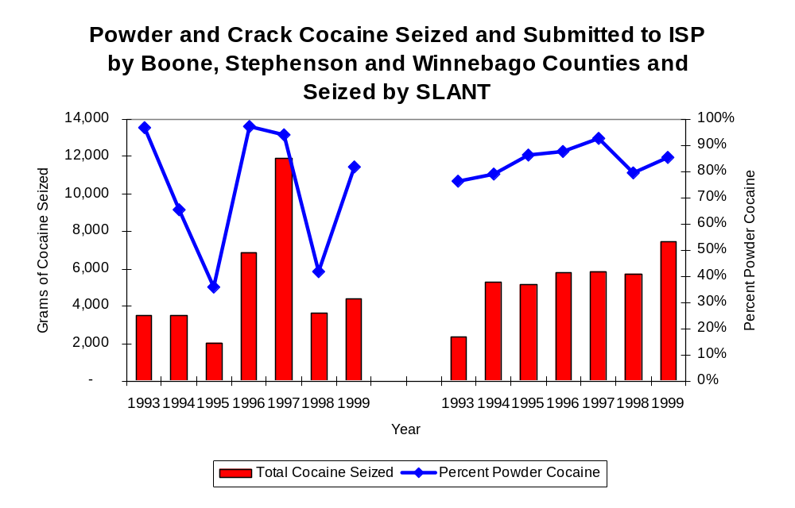
Figure 16
Source: Illinois State Police and SLANT
SLANT
Region

The total quantity of illegal drugs seized and submitted by law enforcement agencies in Boone, Stephenson and Winnebago counties increased between 1993 and 1999, from 86,821 grams to 100,534 grams. On the other hand, the total quantity of illegal drugs seized by SLANT has decreased 69 percent, from 333,594 grams in 1993 to 103,610 grams in 1999.

During the period, methamphetamine seizures accounted for a relatively small proportion of total drugs seized by SLANT. However, in 1999, 1,573 grams of methamphetamine were seized by SLANT resulting in a seizure rate of 1,554 grams per 100,000 population, significantly higher than statewide and regional seizure rates of 98 and 0.11 grams per 100,000 population, respectively (Map 4).

Trends in Prosecutions for Drug Offenses and All Felonies

Although Illinois has one of the best court reporting systems in the country, the Administrative Office of the Illinois Court only collects information regarding the aggregate number of court filings. Currently, there are no statewide data available on court filings by offense type. The Administrative Office of the Illinois Courts reports data on felony criminal court cases. After screening a case and deciding it warrants further action, the state’s attorney must file formal charges in court. Felony cases can be punished by a probation term up to four years and incarceration for more than one year.

Between 1989 and 1999, the number of felony filings in the three-county region covered by SLANT increased 66 percent, from 2,556 to 4,233 (Figure 17).

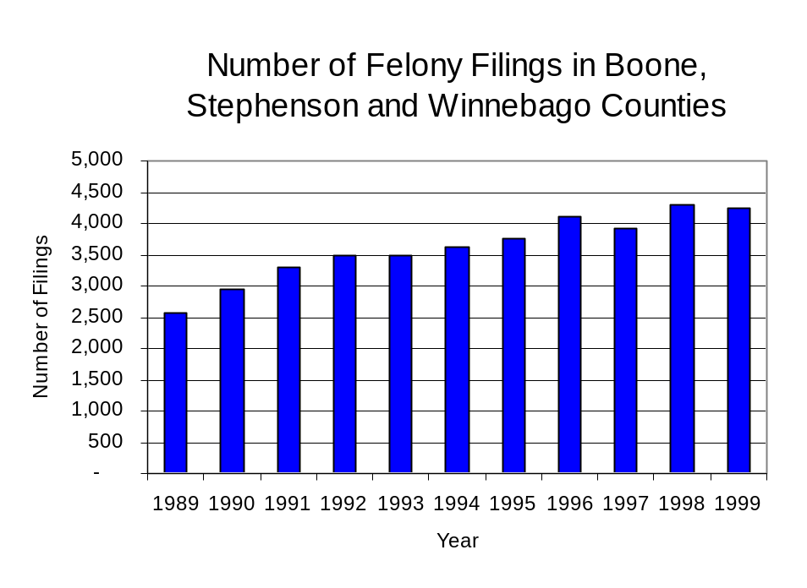
Figure 17
Source: Administrative Office of the Illinois Courts

Between 1989 and 1999, there were a total of 1,189 drug prosecutions initiated as a result of SLANT arrests in Boone, Stephenson and Winnebago counties. During this time, the number of SLANT drug arrests increased 46 percent, from 104 arrests in 1989 to 152 arrests in 1999 (Figure 18). Between 1990 and 1992, 62 percent of all drug arrests by SLANT resulted in prosecution, whereas, during the remainder of the period analyzed, all SLANT drug arrests resulted in a prosecution. The majority (62 percent) of SLANT drug offender prosecutions during this period was for violations of the Controlled Substance Act. In some years, the proportion of arrests resulting in a prosecution exceeded 100 percent. This is due to some slight differences in the timing of an arrest and the filings of charges, or could be due to charges, rather than defendants, being reported by the unit. In addition, some offenders have charges filed, and a subsequent warrant issued, without an arrest taking place.

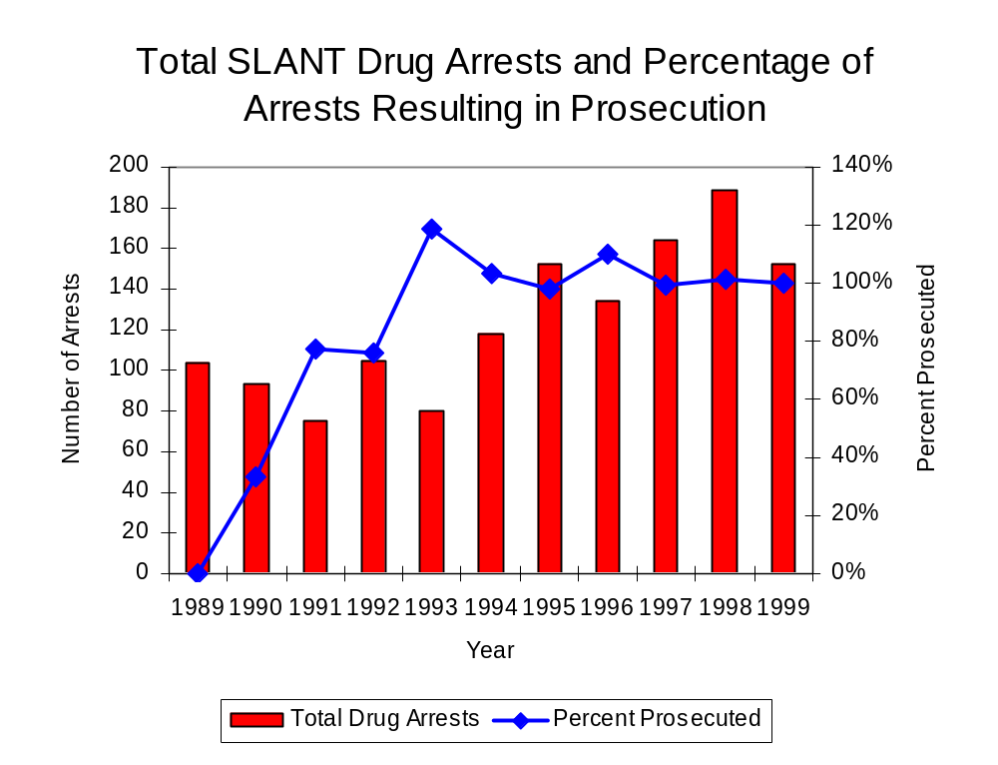
Figure 18
Source: SLANT

Between 1989 and 1999, more than three-quarters (914) of the 1,189 drug offenders who were prosecuted as a result of SLANT activity were convicted. Convictions for controlled substances accounted for 63 percent of all SLANT initiated convictions during the period analyzed.

VI. Trends in Percent of Convicted Drug Offenders Sentenced to Prison

Anyone convicted of a felony in Illinois can be sentenced either to prison or probation, or receive conditional discharge. A number of factors influence the type and length of sentence imposed on convicted felons, including the severity of the crime, the offender’s criminal and social history, safety of the community and legislation affecting certain types of offenses. For some types of convictions, a sentence to prison is required by state statute.

Between 1989 and 1999, the number of offenders convicted of a felony and sentenced in the three-county region covered by SLANT decreased 12 percent, from 955 to 838. Although the number of convicted felons sentenced to the Illinois Department of Corrections (IDOC) decreased between 1989 and 1999, from 368 to 326, the proportion of felons sentenced to IDOC remained unchanged at 39 percent in both 1993 and 1999. In 1999, 480 probation sentences were imposed on convicted felons, 17 percent less than in 1989 (Figure 19). As a result, the proportion of felons sentenced to probation decreased from 61 percent in 1989 to 57 percent in 1999. Sentences other than prison or probation account for the remaining 4 percent of felony sentences imposed in 1999.

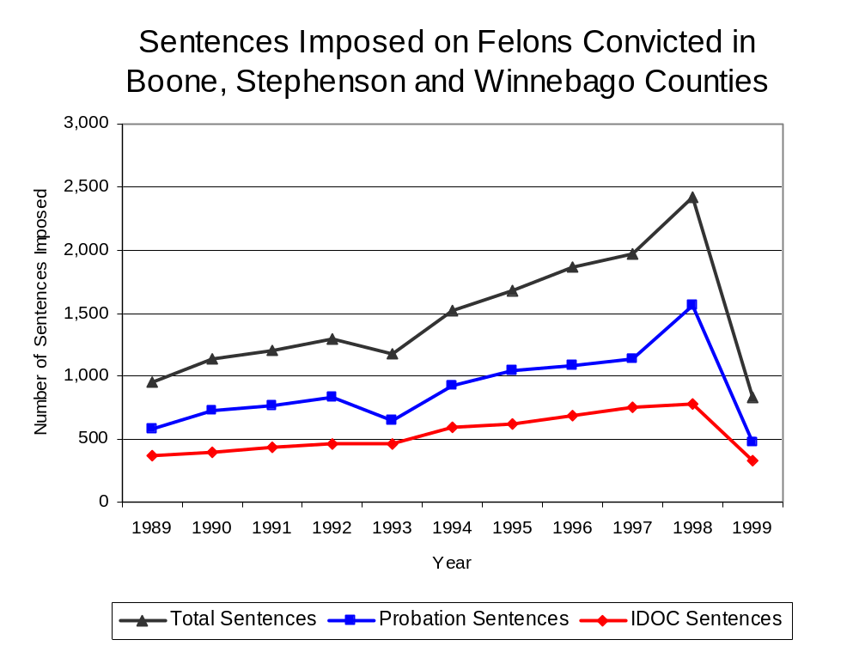
Figure 19
Source: Administrative Office of the Illinois Courts

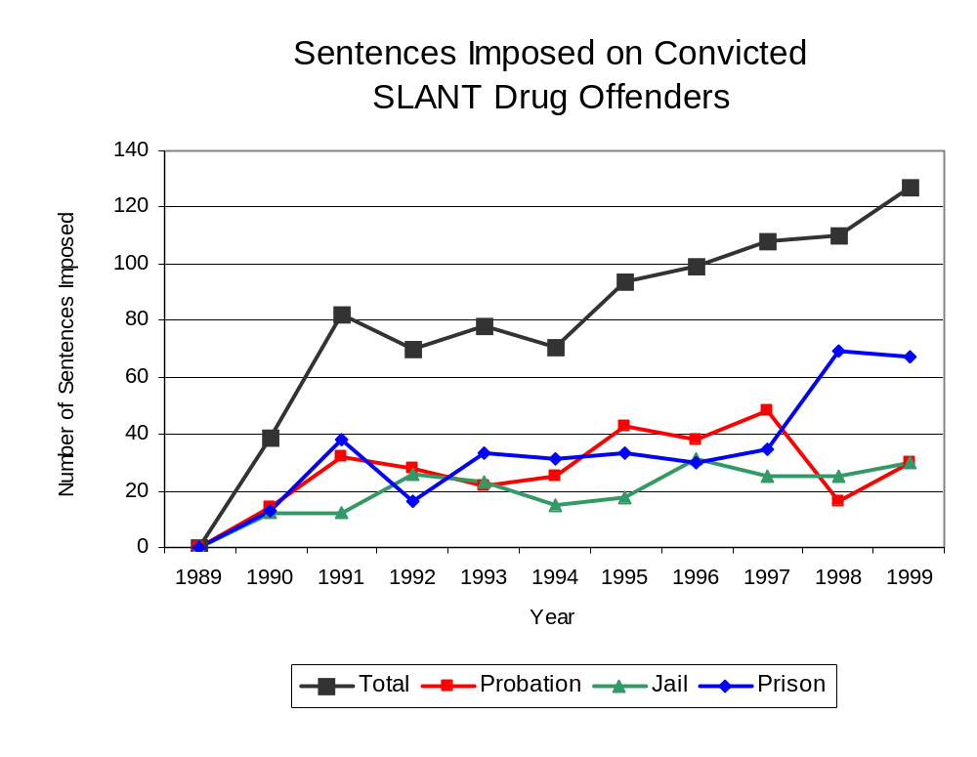
Between 1989 and 1999, the number of SLANT drug offenders convicted and sentenced increased from zero to 127. During the period analyzed, the number of convicted SLANT drug offenders sentenced to probation or jail each increased from zero in 1989 to 30 in 1999, while the number of convicted SLANT drug offenders sentenced to prison increased from zero to 67 (Figure 20). In 1999, among those SLANT drug offenders convicted and sentenced, prison sentences accounted for the largest proportion (53 percent), followed by probation sentences (24 percent) and jail sentences (24 percent).
Figure 20
Source: SLANT

Between state fiscal years 1989 and 1999, the number of new court commitments to IDOC’s Adult Division for drug offenses from the three-county region covered by SLANT more than quadrupled, from 48 to 219. The number of drug offender admissions by SLANT also increased from zero to 58 between 1989 and 1999 (Figure 21). Thus, during the period analyzed, prison sentences resulting from SLANT cases accounted for nearly one-quarter (24 percent) of all drug-law violators sentenced to prison from the region where SLANT operates.
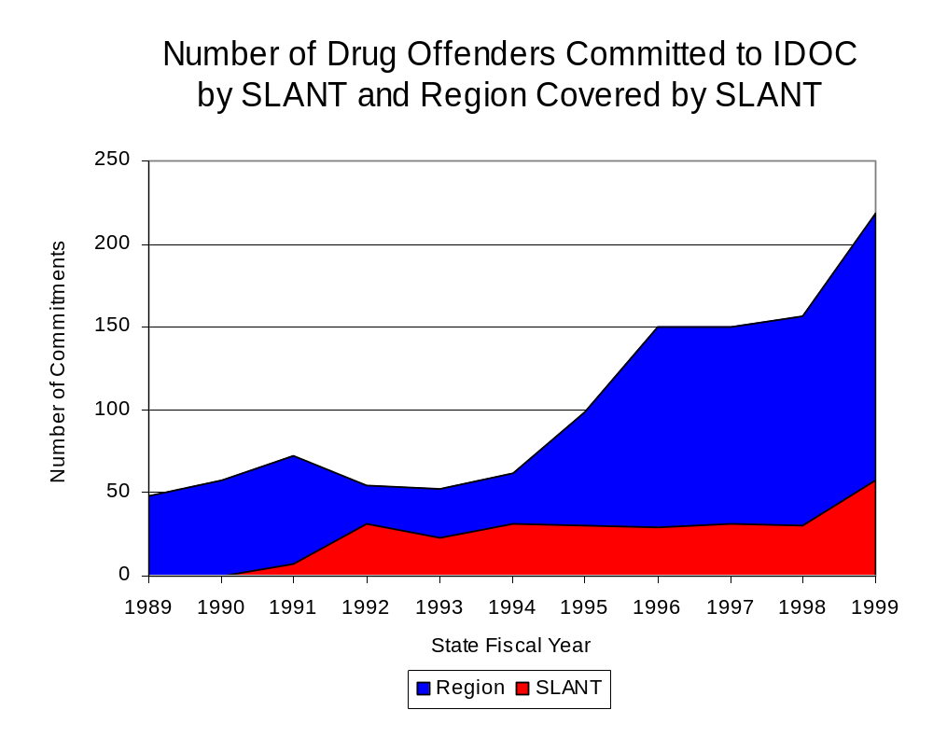
Figure 21
Source: Illinois Department of Corrections and SLANT

During the period analyzed, drug offenders accounted for an increasing proportion of adults convicted and sentenced to prison from Boone, Stephenson and Winnebago counties. In 1989, drug offenses accounted for 15 percent of all commitments to IDOC, compared to 31 percent in 1999 (Figure 22).

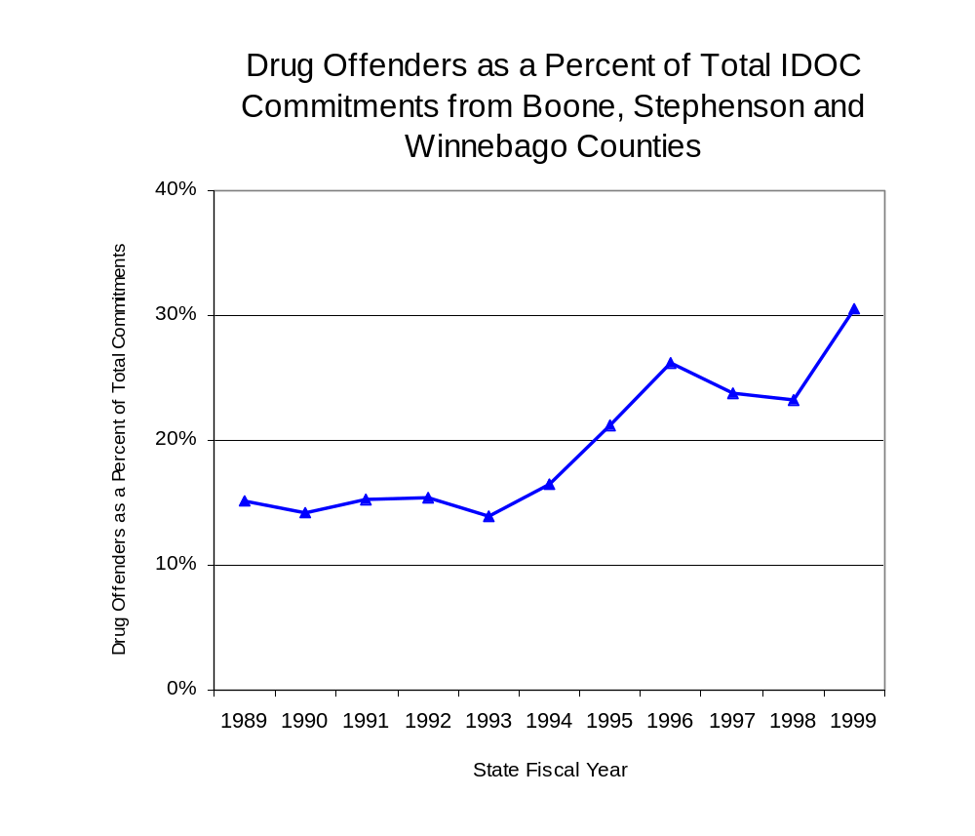
Figure 22
Source: Illinois Department of Corrections

Penalties for drug offenses were also examined between 1993 and 1999. Class 1 felonies accounted for the largest proportion (43 percent) of sentences to IDOC for drug offenses, followed by Class 4 felonies (29 percent), Class X and Class 2 felonies (12 percent each) and Class 3 felonies (3 percent). Between 1993 and 1999, the number of Class 1 felony sentences increased nearly five-fold, from 18 to 99, while Class 4 felony sentences increased more than seven-fold, from ten to 82 and Class 2 felony sentences more than doubled, from nine to 22. The number of Class X and Class 3 felonies remained unchanged at 13 and three, respectively, during the period analyzed (Figure 23).

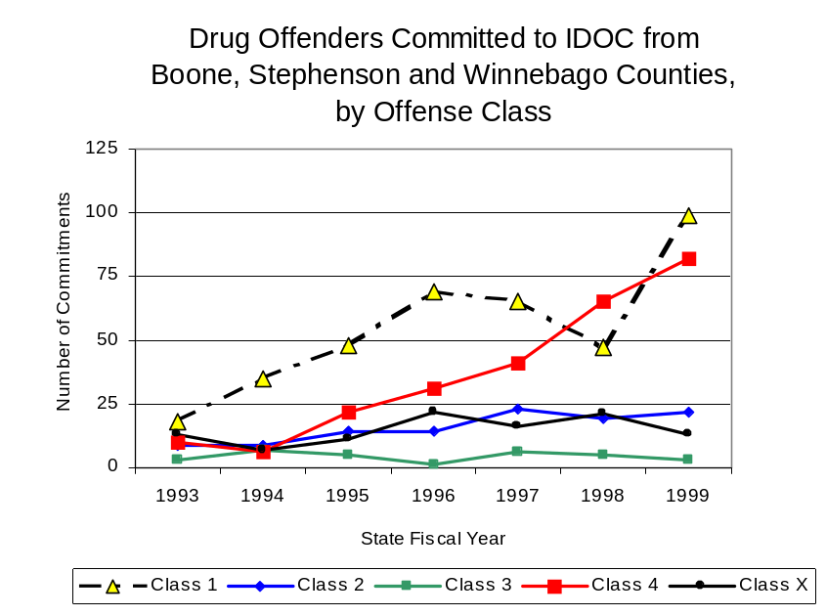
Despite the dramatic increase in Class 4 felony sentences to IDOC between 1993 and 1999, the mean sentence length for Class 4 felonies remained unchanged at 2.33 years, during the period. However, the mean sentence length for Class 2 felonies increased 39 percent, from 3.2 to 4.4 years, while the mean sentence for a Class 1 felony increased 7 percent, from 5.22 to 5.56 years, and Class X sentence lengths increased only slightly, from 10.15 to 10.23 years. Conversely, the mean sentence length for Class 3 felonies decreased slightly, during the period analyzed, from four to 3.33 years.
Figure 23
Source: Illinois Department of Corrections

Based on data collected from the 2000 Illinois Adult Probation Outcome Study, almost one-quarter (24.2 percent) of all adults discharged from probation in Boone, Stephenson and Winnebago counties combined during the study period (November 2000) were convicted of drug-law violations. Of these drug-law violators discharged from probation in the three county region, two-thirds (66.7 percent) had been convicted of a felony drug offense. In addition, more than three-quarters (79.2 percent) of these drug-law violators were ordered to participate in some form of treatment, and each was ordered to pay, on average, $1,442 in the form of supervision, fees, court costs and fines.

VII. Trends in Drug Treatment Admissions in SLANT Region by Drug Type

In addition to considering indicators of the extent and nature of drug abuse as reported through the criminal justice system (for example, arrests and prison sentences), there are indicators of substance abuse available from other Illinois social service agencies. Overseeing and supporting treatment for substance users, whether they are referred from the criminal justice system or elsewhere, is the responsibility of the Illinois Department of Human Services’ Office of Alcoholism and Substance Abuse (OASA). It is important to note, however, that while OASA data represent the majority of the overall demand for substance abuse treatment in the state, some private programs provide treatment services to a smaller but significant number of clients who may not be included in the state’s reporting system.

In state fiscal year 1999, OASA reported 5,153 admissions for alcohol or drug abuse treatment from Boone, Stephenson and Winnebago counties, 48 percent more than the 3,483 admissions in 1989 (Figure 24). Among the 5,153 admissions to substance abuse treatment in state fiscal year 1999, 39 percent (2,002) reported alcohol as their primary substance of abuse, while abuse of illicit substances accounted for more than one-half (57 percent) and 4 percent reported no primary substance of abuse.

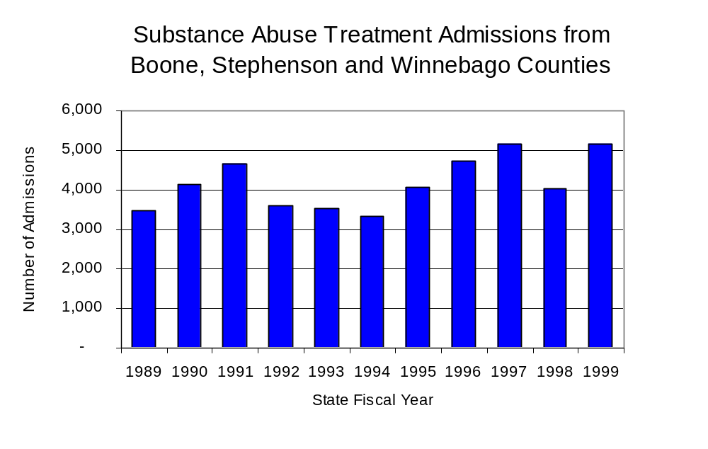
Figure 24
Source: Illinois Department of Human Services’
Office of Alcoholism and Substance Abuse
While drug treatment admissions can be considered a measure of the demand placed on a specific component of the human services system within Illinois, the extent and nature of drug treatment admissions could also be indicative of the substance abuse problem within a particular region. In some respects, the characteristics of those admitted to drug treatment can be considered a profile of the most serious drug abusers in the community, since admission to treatment requires a documented, formal assessment of a drug problem and a level of substance abuse warranting treatment. By comparing the types of drugs of abuse reported by those admitted to substance abuse treatment with the types of drugs involved in law enforcement agency arrests, one can get a sense of the degree to which arrests reflect the drugs which are most problematic within a community.

In the following analyses, the percent of arrests accounted for by drugs classified under Illinois’ Controlled Substances Act (primarily cocaine, heroin, and methamphetamine) versus the Cannabis Control Act (marijuana) across the participating agencies combined, non-participating agencies combined and SLANT are compared to the proportion of drug treatment admissions accounted for by these groups of substances. From these comparisons, a number of general conclusions can be made. First, the proportion of arrests made by SLANT accounted for by drugs other than marijuana (Controlled Substances Act offenses) was very close to the proportion of drug treatment admissions from the covered region accounted for by these substances. Thus, there is considerable convergence between the drugs involved in SLANT arrests and treatment admissions. On the other hand, the majority of arrests by local police departments (including those participating in SLANT and non-participating agencies) were for cannabis offenses. Thus, while local arrests may reflect the most widely available and used drug in the region, they tend not to involve the substances considered to be most serious (i.e., felony versus misdemeanor) nor the substances individuals are seeking and receiving treatment for (Figure 25).

Similar to drug treatment admissions, arrests for controlled substances violations accounted for the majority (81 percent) of SLANT's drug arrests in 1999, compared to 19 percent for cannabis violations. Conversely, the proportion of controlled substances arrests by agencies participating in SLANT accounted for just 17 percent of drug arrests reported in 1999, while 83 percent of participating agency drug arrests were for cannabis violations. In 1999, cannabis arrests also accounted for the majority (57 percent) of drug arrests made by those agencies that do not participate in SLANT, compared to 43 percent for arrests for controlled substances violations.
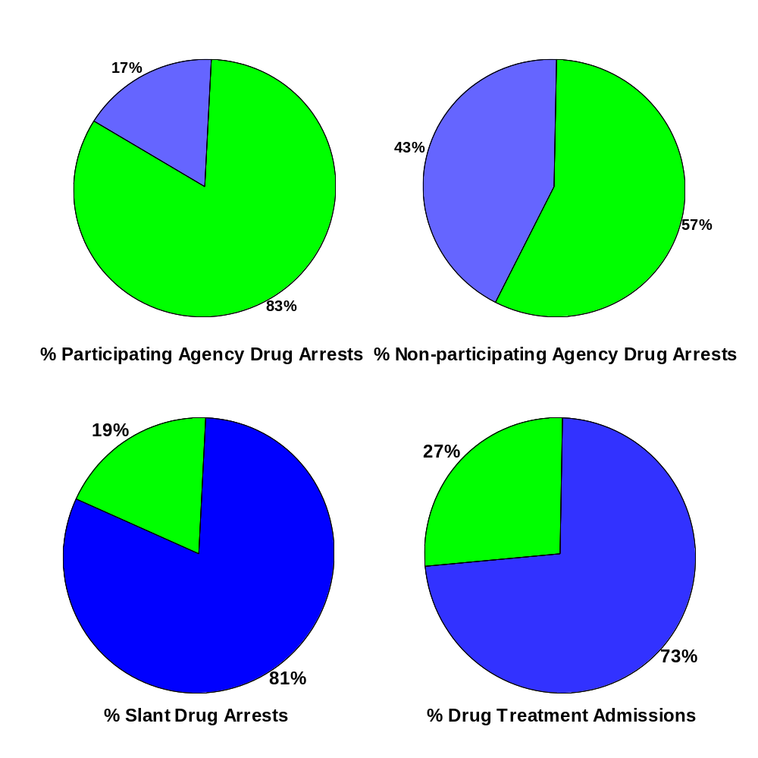
CannabisControlled Substances
Source: ICJIA calculations using Illinois Department of Human Service's Office of Alcoholism and Substance Abuse and SLANT data
Comparison of Drug Arrests by SLANT and Participating and
Non-participating Agencies vs. Drug Abuse Treatment Admissions in Boone, Stephenson and Winnebago Counties, 1999
Figure 25

VIII. Trends in Drug Exposed Births

Illinois continues to experience the effects of prenatal substance abuse. In Illinois, if a baby is born and thought to have been exposed to illegal substances or alcohol, either through observation by physicians or toxicology tests, the case is reported to the Illinois Department of Children and Family Services. These cases are then investigated by DCFS to verify the child’s prenatal exposure to either alcohol or illegal substances. Between state fiscal years 1989 and 1999, nearly one-half (50) of Illinois’ 102 counties reported at least one case of a substance-affected infant.

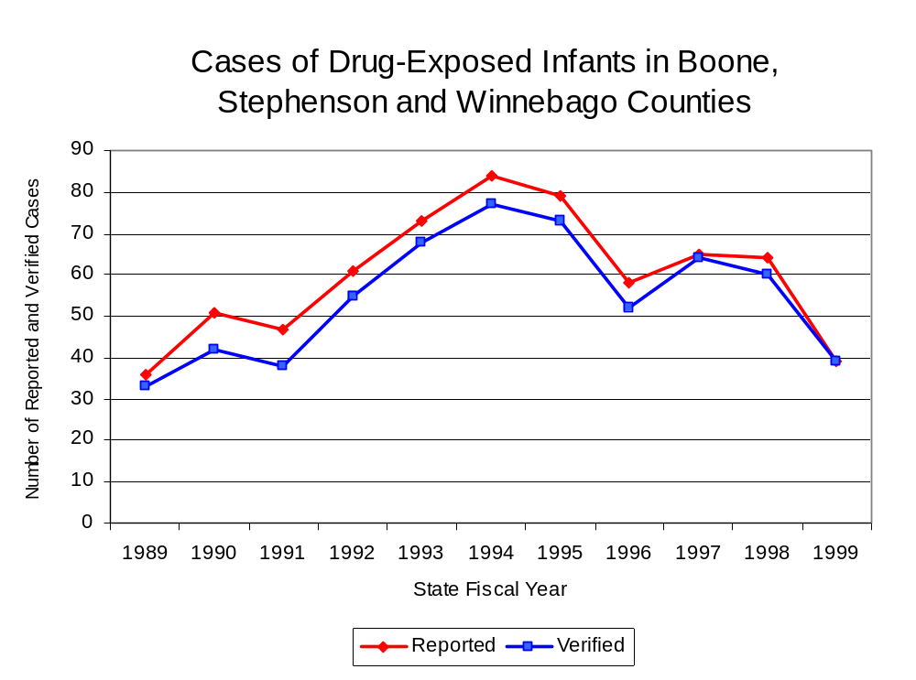
Between state fiscal years 1989 and 1994, the number of drug-exposed infant cases reported in the three-county region covered by SLANT soared from a period low of 36 to a period high of 84, before decreasing almost every year since to 39 in 1999. Between state fiscal years 1989 and 1999, 601 cases, or 91 percent of all cases reported, were verified as involving prenatal drug use by a DCFS investigation. Mirroring the trend of reported cases, verified cases of drug-exposed infants in the SLANT region also jumped dramatically between 1989 and 1994 from 33 to 77 before dropping to 39 cases in 1999 (Figure 26).
Source: Department of Children and Family Services
Figure 26

Summary of Drug Situation

Although the distribution of illegal drugs is difficult to measure precisely, data obtained from criminal justice sources can be helpful in estimating drug availability. Information from a recent survey of Illinois drug enforcement units, as well as the most up-to-date data available on drug price, are presented as indicators of the drug supply in Illinois.

In 1995, 1996 and 1998, the Authority conducted a survey of each MEG and task force in Illinois to gauge the perceived availability of drugs in the areas they cover. Questions were asked concerning the availability of specific drugs, and results were analyzed by region of the state. MEGs and task forces are classified as being either urban, rural or mixed urban/rural based upon the classification of the county(s) that each unit covers, and, for purposes of this report, are compared to the average of similar units.

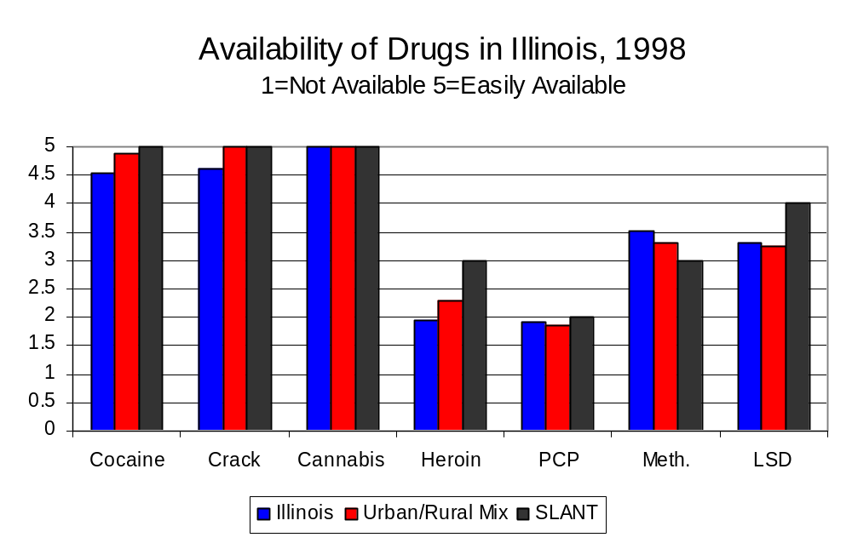
According to SLANT survey responses, cannabis, cocaine and crack continued to be the most visible drugs on the street and were all reported to be “readily available” across all regions analyzed. While perceived availability of most drugs remained relatively unchanged in the three-county region covered by SLANT, the perceived availability of LSD has decreased slightly since the 1996 survey, while all other drug types increased slightly across Illinois and all MEGs and task forces in mixed urban/rural regions similar to SLANT. Methamphetamine was reported as moderately available across Illinois but available to a somewhat lesser degree in the region covered by SLANT and by all MEGs and task forces in mixed urban/rural regions. On the other hand, LSD and heroin appear to be more readily available in the three-county region covered by SLANT than across the state and all other MEGs and task forces in mixed urban/rural regions (Figure 27).
Figure 27
Source: Authority Survey of Illinois MEGs and task forces
Another market indicator that can be used to assess availability is drug price. Lower prices tend to suggest a sufficient supply to meet demand, while increasing prices indicate decreased availability.

Based on a statewide survey of MEG and task force units, the average price of cocaine, crack and methamphetamine appear to be relatively stable across all regions surveyed in 1998, while prices for PCP and heroin appear to vary somewhat across Illinois. The average price of cannabis, cocaine and heroin in the region covered by SLANT decreased between 1996 and 1998, while it increased in the other mixed urban/rural regions. The 1998 average price of cocaine reported by SLANT was $100 per gram, compared to $98 per gram across Illinois and $103 per gram reported by all MEGs and task forces in other mixed urban/rural regions (Figure 28). On the other hand, the average price of heroin in the region covered by SLANT was reported as $125 per gram, lower than the price of $165 per gram across Illinois and the price of $214 per gram reported by all other MEGs and task forces in mixed urban/rural regions. In 1998, the average price of cannabis was reported as approximately $8 per gram in the SLANT region, $7 per gram in primarily mixed urban/rural regions and $8 per gram across Illinois.

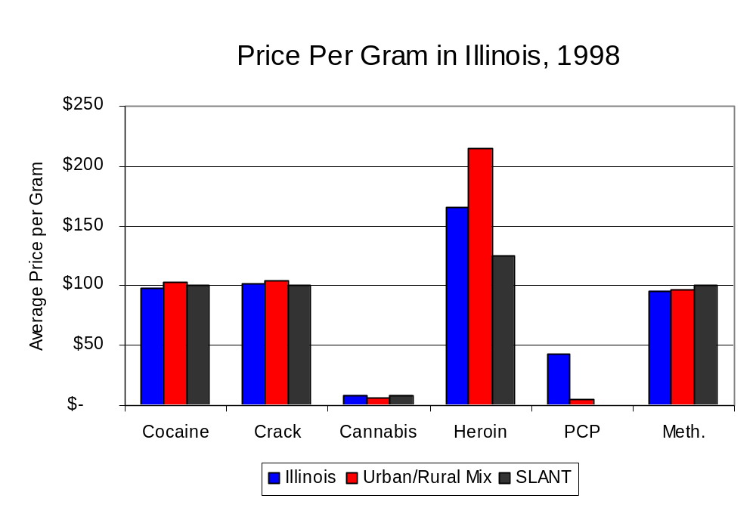
Figure 28
Source: Authority Survey of Illinois MEGs and task forces

X. Appendices
1999 Percent of Illinois'
County-level Population Covered by an Authority-funded Multi-jurisdictional Enforcement Group or Task Force
Map 1
* Shaded counties indicate that at least one law enforcement agency within the county participates in a MEG or task force
Percent of County Population Covered by MEG or Task Force

1999 Illinois
Cannabis
Seizure Rates, by County
Map 2
Cannabis Seizure Rate
(rate per 100,000 population)
1999 Illinois
Cocaine
Seizure Rates, by County
Map 3
Cocaine Seizure Rate
(rate per 100,000 population)
1999 Illinois Methamphetamine
Seizure Rates, by County
Map 4
Methamphetamine Seizure Rate
(rate per 100,000 population)

Bibliography

Administrative Office of the Illinois Courts, Annual Report to the Supreme Court of Illinois.
1989 through 1999 reports, Springfield, Illinois.

Administrative Office of the Illinois Courts’ Probation Division, Statewide Probation Data
Report. 1989 through 1999 reports, Springfield, Illinois.

Illinois Department of Human Services’ Office of Alcoholism and Substance Abuse. Data
provided for state fiscal years 1989 through 1999, Springfield, Illinois.

Illinois Department of Children and Family Services, Child Abuse/Neglect Statistics Report,
1989 through 1999 reports, Springfield, Illinois.

Illinois Department of Corrections. Data provided for fiscal years 1989 through 1999,
Springfield, Illinois.

Illinois State Police, Crime in Illinois. 1993 through 1999 reports, Springfield, Illinois.

Illinois State Police, Drug Statistics Report. Monthly reports, January 1989 through
December 1999, Springfield, Illinois.

State Line Area Narcotics Team. Monthly reports, January 1989 through December
1999, Rockford, Illinois.

U.S. Bureau of the Census.


George H. Ryan, Governor
Peter B. Bensinger, Chairman
Candice M. Kane, Executive Director

